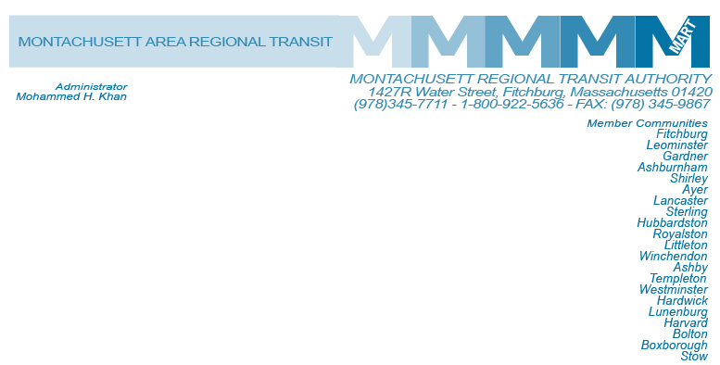

Posted 10/08/2015 at 1:49 pm by JAV

MART Maintenance Facility
1427R Water Street
Fitchburg, MA 01420

MEETING OF THE MART Executive COmpensation COmmittee

Tuesday, October 13, 2015
3:00 P.M.

Agenda

- What Constitutes Executive Compensation
- Executive Compensation-Audit Filing
- Planned/Future Changes to Executive Compensation
- Open Items
- Adjournment

